**Draw the detailed flowchart of the following problems. Mention your assumptions. Make a sufficient number of dry runs to test your algorithm.**

**a. Frequency Analysis of Characters and Reserved Words in a C Program**

**Flow chart**

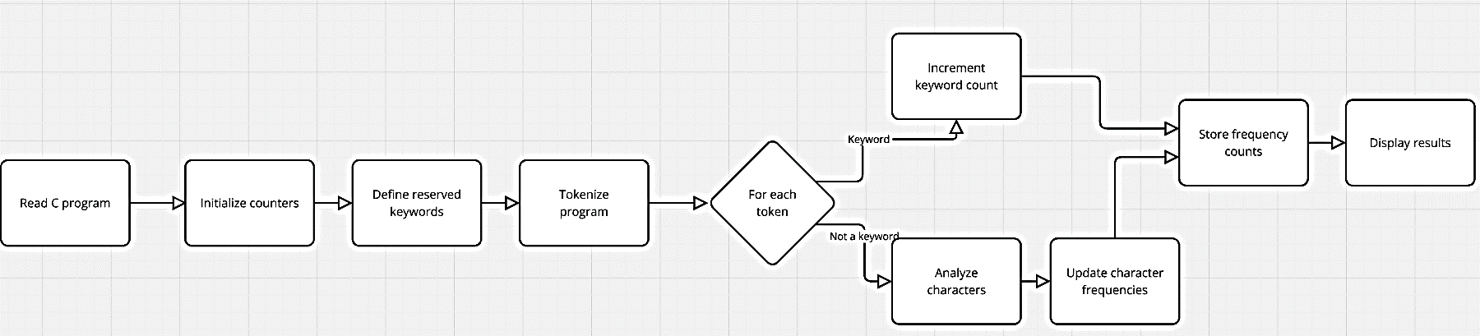

**Algorithm**

Start:  
Step 1: Read the input C program as a string or line by line.  
Step 2: Initialize counters for alphabets, digits, special characters, and whitespace.  
Step 3: Define a list of reserved keywords in C.  
Step 4: Tokenize the program into words.  
Step 5: For each token:

* Check if it matches any reserved keyword.
* If it is a reserved keyword, increment its count.
* If not, analyze its characters and update their frequencies.

Step 6: Store the frequency counts for each character and reserved word.  
Step 7: Display the frequency results.  
End

**b. Generate All Permutations of n Characters**

**Flow chart:**

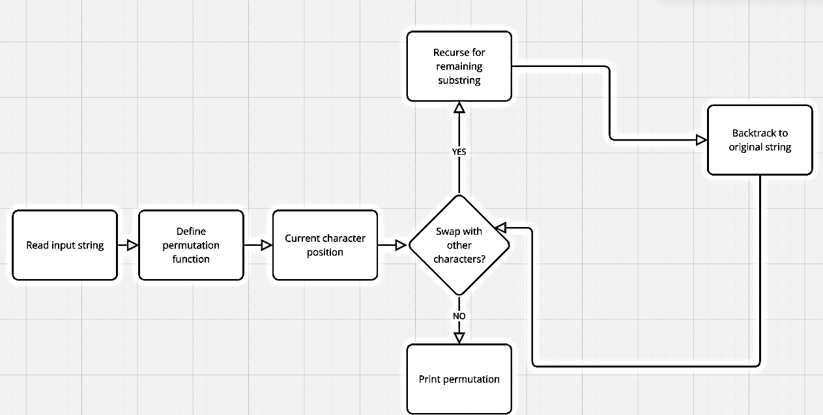

**Algorithm**

Start:  
Step 1: Read the input string of n characters.  
Step 2: Define a function for generating permutations recursively.  
Step 3: For the current character position:

* Swap the current character with every other character.
* Recurse to generate permutations for the remaining substring.
* Backtrack by swapping back to restore the original string.

Step 4: Print each generated permutation.  
End

**c. Convert Integer to Roman and Vice Versa**

**Flowchart :**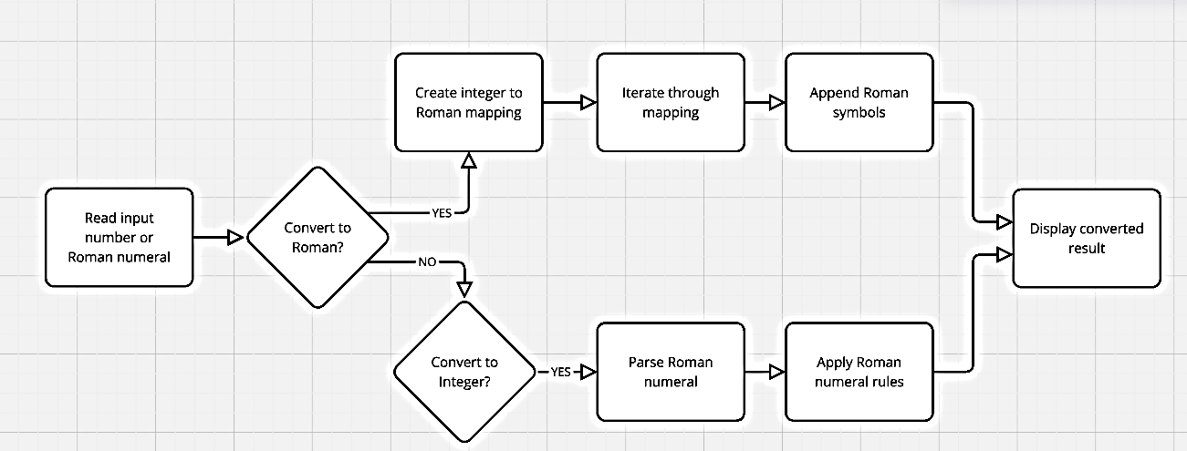

**Algorithm :**

Start:  
Step 1: Read the input number or Roman numeral.  
Step 2: If converting integer to Roman:

* Create a mapping of integers to Roman numeral symbols.
* Iterate through the mapping in descending order.
* Append Roman symbols while subtracting their values from the input number.  
  Step 3: If converting Roman to integer:
* Parse the Roman numeral from left to right.
* Add or subtract values based on Roman numeral rules.s

Step 4: Display the converted result.  
End

**d. Evaluate Arithmetic Expression**

**Flowchart :**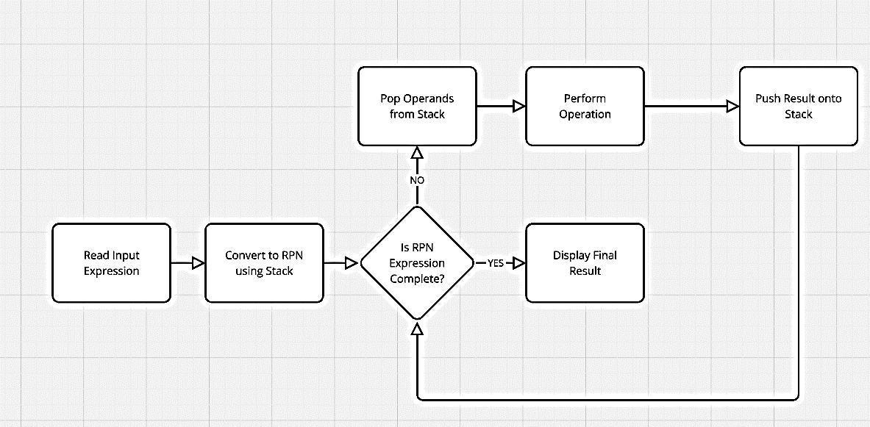

**Algorithm :**

Start:  
Step 1: Read the input arithmetic expression.  
Step 2: Convert the expression into Reverse Polish Notation (RPN) using a stack.  
Step 3: Evaluate the RPN expression:

* For each operator, pop operands from the stack.
* Perform the operation and push the result back onto the stack.

Step 4: Display the final result from the stack.  
End

**e. Find Execution Time of a Program Without Timestamps**

**Flowchart :**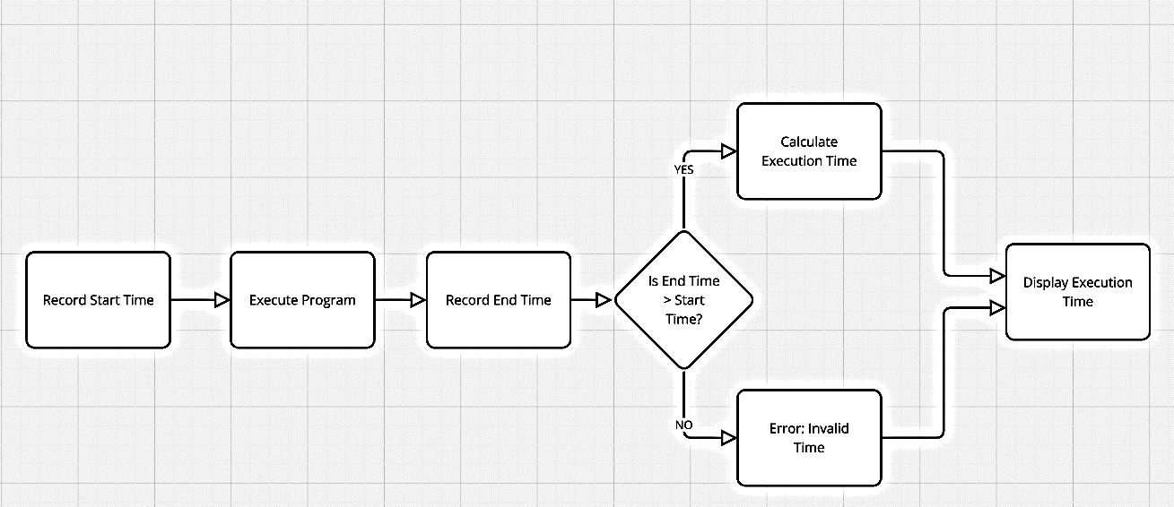

**Algorithm :**

Start:  
Step 1: Use a function like clock() to record the program's start time.  
Step 2: Execute the program or function to be measured.  
Step 3: Record the program's end time using clock().  
Step 4: Calculate the execution time as (end_time - start_time) / CLOCKS_PER_SEC.  
Step 5: Display the execution time.  
End

**f. Matrix Multiplication of Large Matrices**

**Flowchart :**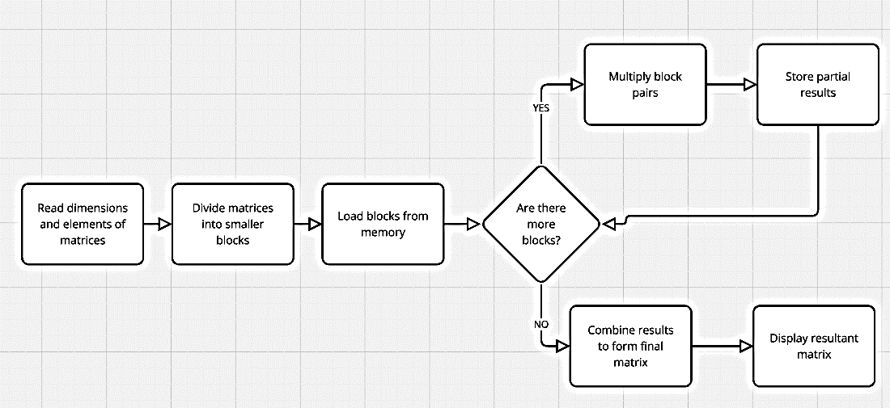

**Algorithm :**

Start:  
Step 1: Read the dimensions and elements of two matrices.  
Step 2: Divide the matrices into smaller blocks that fit into memory.  
Step 3: Multiply corresponding blocks of matrices:

* Load blocks from memory.
* Perform multiplication for each block pair.
* Store partial results in a temporary matrix.

Step 4: Combine the results to form the final matrix.  
Step 5: Display the resultant matrix.  
End

**g. Find Maximum Polygon from Points**

**Flowchart :**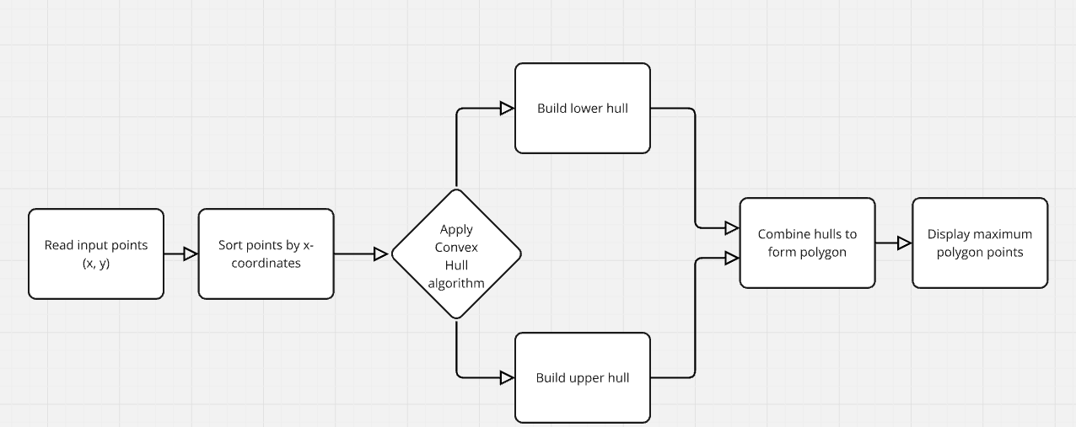

**Algorithm :**

Start:  
Step 1: Read the input set of points (x, y).  
Step 2: Sort the points based on x-coordinates.  
Step 3: Apply the Convex Hull algorithm:

* Build the lower hull by iterating over the sorted points.
* Build the upper hull in reverse order.

Step 4: Combine the upper and lower hulls to form the convex polygon.  
Step 5: Display the points that form the maximum polygon.  
End

**h. Factorial of an Integer (Up to 10-Digit Numbers)**

**Flowchart :**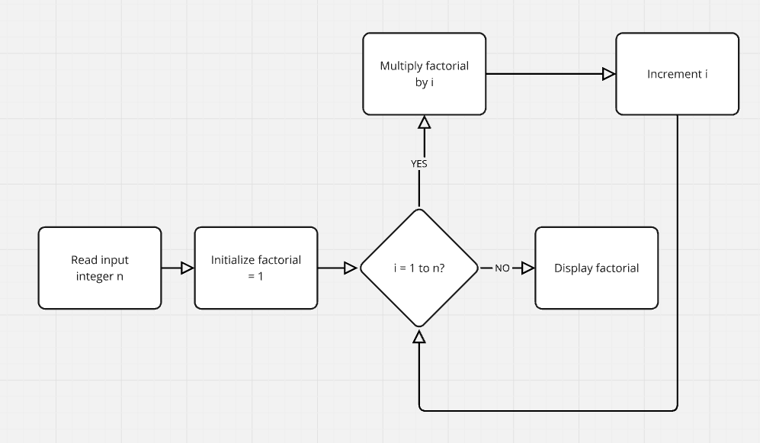

**Algorithm :**

Start:  
Step 1: Read the input integer n.  
Step 2: Initialize a variable factorial = 1.  
Step 3: For i = 1 to n:

* Multiply factorial by i.

Step 4: Display the value of factorial.  
End